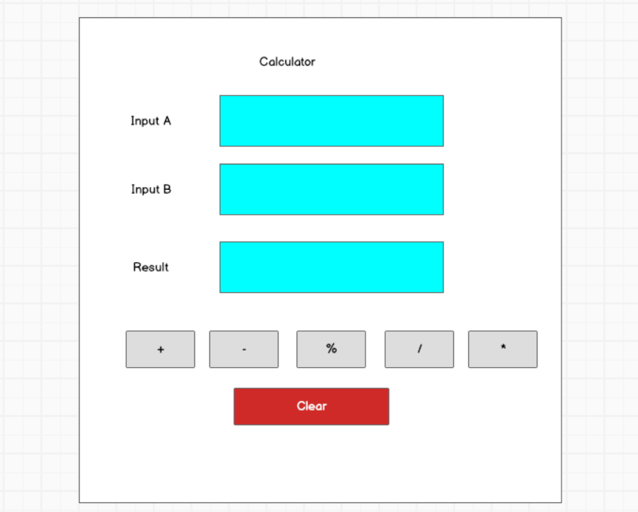

|  |  |  |  |
| --- | --- | --- | --- |
| **ID** | **Condition** | **Control Type** | **Target** |
| 1 | Press | Input text | Enter the first number |
| 2 | Press | Input text | Enter the second number |
| 3 | Press | Button | Click to perform the addition operation and display the result |
| 4 | Press | Button | Click to perform the subtraction operation and display the result |
| 5 | Press | Button | Click to perform the modulo division operation and display the result |
| 6 | Press | Button | Click to perform the division operation and display the result |
| 7 | Press | Button | Click to perform the multiplication operation and display the result |
| 8 | Press | Button | Click to reset the input fields to their initial state |